**MultiPlay / DualPlay**

# **Setup**

1. From Tools > MultiPlay > Client Manager

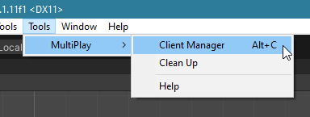

1. Click Create Client. The button will be deactivated as long as the client window is open

Note: MultiPlay Supports a total of 4 windows (including the original project window) while DualPlay only supports 2

**Note:**   
Enabling Link Library Option is recommended and will result in faster clones creation; However, it may not work well on larger projects so keep this in mind if clones start failing and recreate them without the Link Library option

Button will reactivate upon closing client window

1. On the newly launched unity project, again, From Tools > MultiPlay > Client Manager. Only this time you will get a different tool window.

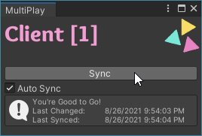

1. Make any changes to your scene in the original project editor and CLICK SAVE IN THE ORIGINAL PROJECT to propagate the changes across all launched clients.
2. Unless [Auto Sync] is ticked at the client side, you will have to press the [Sync] button every time you make changes to the original project.

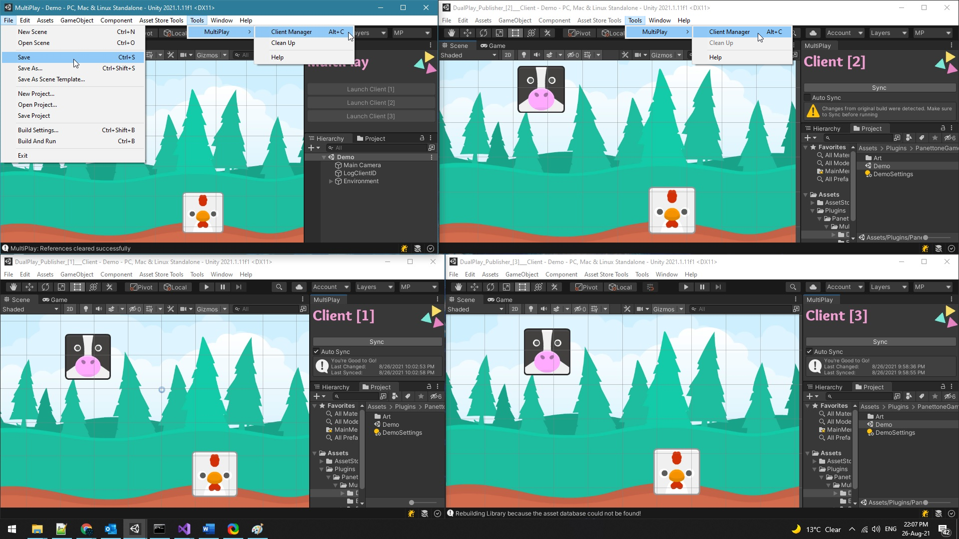

**3**

**1**

+

**5**

**4**

**2**

[](https://panettonegames.com/)

# **Common Questions & Issues**

**Which Client?**  
To figure out which client you are running, attach the **LogClientID** script to any game object in the scene. Alternatively, you may use the below script

int clientIndex = PanettoneGames.MultiPlay.Utils.GetCurrentClientIndex();

if (clientIndex == 0) Debug.Log("MultiPlay is running on: Main Project/Server");

else Debug.Log($"MultiPlay is running on Client: {clientIndex}");

## **Sharing Violation**

Newer versions may complain about sharing the Library folder amongst clients and although it shouldn’t matter in most cases, you may opt to be on the safer side and turn off the [Link Library] Option from the settings

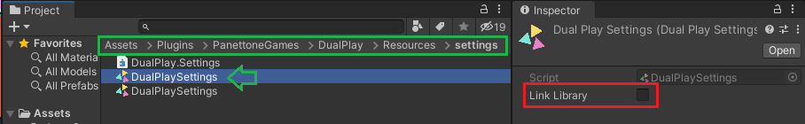

**Note:** In MultiPlay, this is also available in the settings drop down menu below the client buttons.

Alternatively You may simply turn off Unity’s [Directory Monitoring] from: Edit> Preferences> Genera > Directory Monitoring

